



Essay / Assignment Title: Machine Learning Meets Term Life Insurance: Targeting High-Value Customers

Programme title:

Name:

Year:

CONTENTS

CONTENTS 2
INTRODUCTION 4
Overview of the Problem 4
Objectives of the Analysis 4
Dataset Overview 4
Dataset Description 4
CHAPTER ONE: DATA PREPROCESSING AND EXPLORATION 5
2. 1 Data Exploration 5
2.1.1. Objective: 5
2.1.2 Descriptive Statistics for Numerical Features 5
2.1.3 Frequency Analysis for Nominal data 6
2.1.4 Summary of Key Findings 8
2.2 Handling Missing Values and Outliers 9
2.2.1 Identifying Missing Data 9
2.2.3 Techniques on Dealing with Missing Information 9
2.2.4 Outlier Detection Techniques 10
2.2.5 Treatment of Outliers 11
2.2.6 Justification of Chosen Methods 11
2.3 Data Visualization 12
2.3.1 Visualizing Numerical Features 12
2.3.2 Visualizing Categorical Features 12
2.3.3 Depiction of Relations with Target Variable 13
2.3.4 Insights from Visualizations 14
CHAPTER TWO: MODEL SELECTION AND TRAINING 15
3. 1 Model Selection 15
3.1.1 Overview of Binary Classification Algorithms 15
3.1.2 Justification for Choosing Specific Algorithms 15
3.1.2 Summary of Model Selection Process 15
3. 2 Data Splitting 16
3.2.1 Data Splitting (Training & Testing Data Set) 16
3.2.2 Ensuring Stratification of Target Variable 16
3.2.3 Explanatory Information on Data-Splitting Technique 16
3. 3 Model Training 17
3.3.1 Training the Logistic Regression Model 17
3.3.2 Training the Random Forest Model 17
CHAPTER THREE: MODEL INTERPRETATION AND EVALUATION 19
4.1 Model Interpretation 19
4.2 Model Evaluation 19
4.3 Python Code for Model Evaluation 20
4.4 Hyperparameter Tuning 20
4.4.1 Importance of Hyperparameter Tuning: 21
CONCLUDING REMARKS 22
5.1 Summary of Key Insights and Findings 22
5.2 Recommendations for HashSysTech Insurance 22
5.3 Reflection on the Model's Impact on Business Decision-Making 22
BIBLIOGRAPHY 23

LIST OF FIGURES

Figure 1: Jupyter Notebook Code and Output: Descriptive Statistics for Numerical Features 7
Figure 2: Jupyter Notebook Code and Output: Frequency Tables for Categorical Features 8
Figure 3: Jupyter Notebook Code: Identifying Missing Values 11
Figure 4: Jupyter Notebook Code: Imputation of Missing Values 11
Figure 5: Jupyter Notebook Code and Output: Outlier Detection and Handling 12
Figure 6: Jupyter Notebook Code and Output: Outlier Detection and Handling 13
Figure 7: Jupyter Notebook Code: Outlier Removal 13
Figure 8: Jupyter Notebook Code and Output: Age Distribution Histogram 14
Figure 9: Jupyter Notebook Code and Output: Marital Status Distribution 15
Figure 10: Jupyter Notebook Code and Output: Boxplot of Call Duration vs Subscription Status 16
Figure 11: Python code snippet: Data Splitting using train_test_split 18
Figure 12: Jupyter Notebook Code: Stratified Data Splitting 18
Figure 13: Jupyter Notebook Code: Preprocessing Pipeline and Logistic Regression Model 19
Figure 14: Jupyter Notebook Code: Random Forest Model Initialization 20
Figure 15: Jupyter Notebook Code and Output: Logistic Regression Model Evaluation 22
Figure 16: Jupyter Notebook Code and Output: Random Forest Model Evaluation 22

LIST OF TABLES

Table 1: Descriptive Statistics for Numerical Features 9
Table 2:Frequency Analysis for Categorical Features 10
Table 3: Frequency Distribution of Marital Status 10
Table 4: Distribution of Education Qualification 10
Table 5: Distribution of Call Type 11
Table 6: Distribution of Previous Outcome 11
Table 7: Distribution of Target Variable (Y) 11
Table 8: Logistic Regression Classification Report 22
Table 9: Random Forest Classification Report 22

Statement of compliance with academic ethics and the avoidance of plagiarism

I honestly declare that this dissertation is entirely my own work and none of its part has been copied from printed or electronic sources, translated from foreign sources and reproduced from essays of other researchers or students. Wherever I have been based on ideas or other people texts I clearly declare it through the good use of references following academic ethics.
(In the case that is proved that part of the essay does not constitute an original work, but a copy of an already published essay or from another source, the student will be expelled permanently from the postgraduate program).

Name and Surname (Capital letters):

.......................................................................................................................................

Date: ........................./........../.........

INTRODUCTION

Overview of the Problem
Term life insurance is promoted through telemarketing (Gu, J., Na, J., Park, J. and Kim, H., 2021) by the unique HashSysTech Insurance Corporation. Nonetheless, because the cost of these campaigns is relatively steep, the firm aims at minimizing resource utilizations by only focusing on the most prospective client population. The intention is to isolate it and channel telemarketing efforts toward those customers.

Objectives of the Analysis
The goal is to generate a model for the improvement in marketing strategies by providing a list of customers likely to buy term life insurance (Chou, S.F., Horng, J.S., Liu, C.H.S. and Lin, J.Y., 2020). This model will be useful in Project Green light in targeting customers with better chances of responding to telemarketing. Specifically, the analysis aims to:
- Analyze customer-data to find correlations with term life insurance.
- Construct a machine learning model to measure the prospect of conversion from the numerical data obtained.
- Employ statistical analysis and machine learning to help HashSysTech make its best decisions on operations.

Dataset Overview
It includes data of customers whom we have tried to sell our products through telemarketing in the past such as their age, gender, contact details and sales history etc. In this case the target variable reflects if a given customer made the purchase of the insurance product which makes it possible to create a model for future conversion.

Dataset Description
The dataset includes the following components:
- Customer Demographics: Age, position, marital status and level of education.
- Contact Details: Work type that involves calls type, day, month, contact duration and total number of calls completed.
- Campaign History: Prior campaign results (unknown other failure success)
- Target Variable: Whether the customer subscribed to the insurance of not.
With these features, useful customers for telemarketing will be foreseen, thus making telemarketing efforts for HashSysTech Insurance efficient.

CHAPTER ONE: DATA PREPROCESSING AND EXPLORATION

2. 1 Data Exploration

2.1.1. Objective:
In this respect, when attempting to navigate and analyze the structure of the data in the given set where a number of features might be either numeric or categorical, it is crucial to initially sort the data by the presence of this characteristic. Analysis of numerical kind of features will be done by calculating mean, mode standard deviation while the categorical nature of features will be analyzed by performing frequency analysis (Alshdaifat, E.A., Alshdaifat, D.A., Alsarhan, A., Hussein, F. and El-Salhi, S.M.D.F.S., 2021).

2.1.2 Descriptive Statistics for Numerical Features
The following numerical features are examined:
- Age: Growth of the customer.
- Day: The number which indicates the day of the month when the last communication was carried.
- Mon: The month in which the last contact was established.
- Dur: Time elapsed as a result of the last contact in seconds.
- Num_calls: Total call made on the customer, during the campaign.
Some of the main parameters which should be calculated to each feature are mean, median, standard deviation, and range.
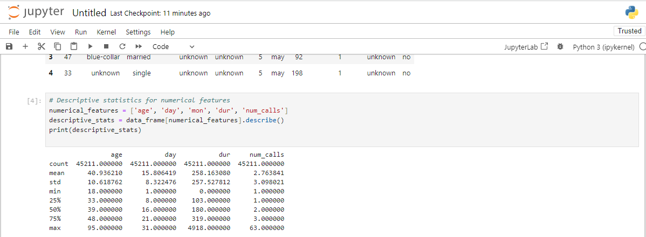
Figure 1: Jupyter Notebook Code and Output: Descriptive Statistics for Numerical Features

Table 1: Descriptive Statistics for Numerical Features
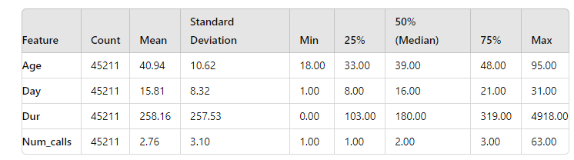

2.1.3 Frequency Analysis for Nominal data
The following categorical features will be analyzed:
- Job: Customer’s occupation.
- Marital: Customer’s marital status.
- Education_qual: Customer’s education level.
- Call_type: The modality of contact which was made with them such as phone, email.
- Prev_outcome: Outcome of the previous campaign (for instance, successes, failures).
- Y: Dependent variable which showed the consumption of the insurance product by the customer.
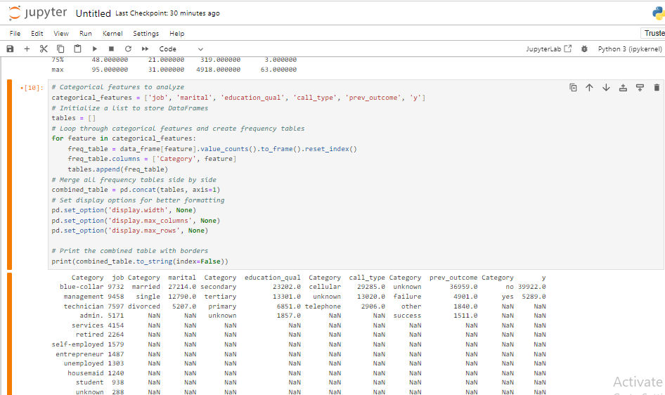
Figure 2: Jupyter Notebook Code and Output: Frequency Tables for Categorical Features
Table 2:Frequency Analysis for Categorical Features
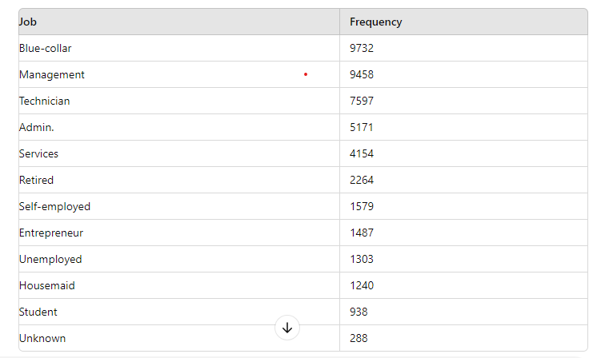
Table 3: Frequency Distribution of Marital Status
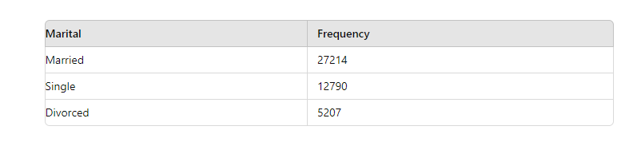
Table 4: Distribution of Education Qualification
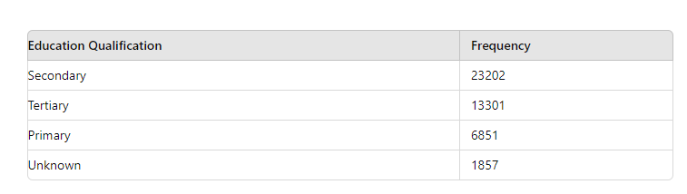
Table 5: Distribution of Call Type
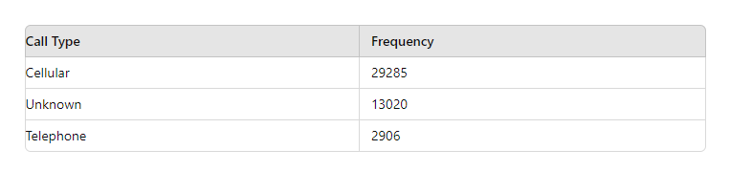
Table 6: Distribution of Previous Outcome
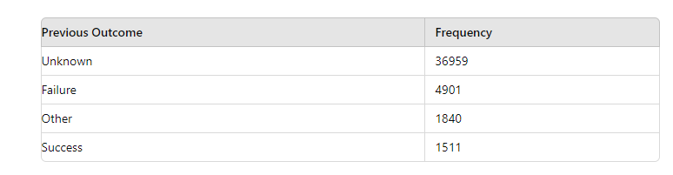
Table 7: Distribution of Target Variable (Y)
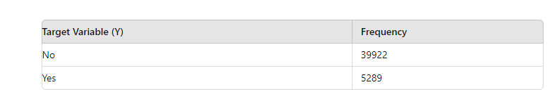

2.1.4 Summary of Key Findings
- Numerical Features: The statistical summary will show an important number of trends for instance the number of calls made and the amount of time used in calls. For instance, volatility in the length of the calls may require a high standard deviation and that may be indicative of the fact that customers are either getting interested or losing interest while a telemarketing call is going on.

- Categorical Features: This will enable frequency analysis of customers’ distribution in terms of their jobs, marital status and education level to be carried out. For instance, if a particular job type (for instance, management) is more effective at conversion, it can be marketed more in future campaigns. In the same way, using the prev_outcome feature may show customers who made positive outcomes to past telemarketing campaigns.
Such conclusions contribute a solid ground to construct effective models and the key variables that can facilitate the enhancement of the telemarketing techniques at HashSysTech Insurance.

2.2 Handling Missing Values and Outliers

2.2.1 Identifying Missing Data
When it comes to handling missing and/or outliers data it is essential to notice that the quality of data is a significant measure for data analysis (Woods, A.D., Davis-Kean, P., Halvorson, M.A., King, K., Logan, J., Xu, M., Bainter, S., Brown, D., Clay, J.M., Cruz, R.A. and Elsherif, M., 2021). Data can be missing for many reasons, including data collection or data entry failure. The first step therefore is to locate these missing values within the dataset.
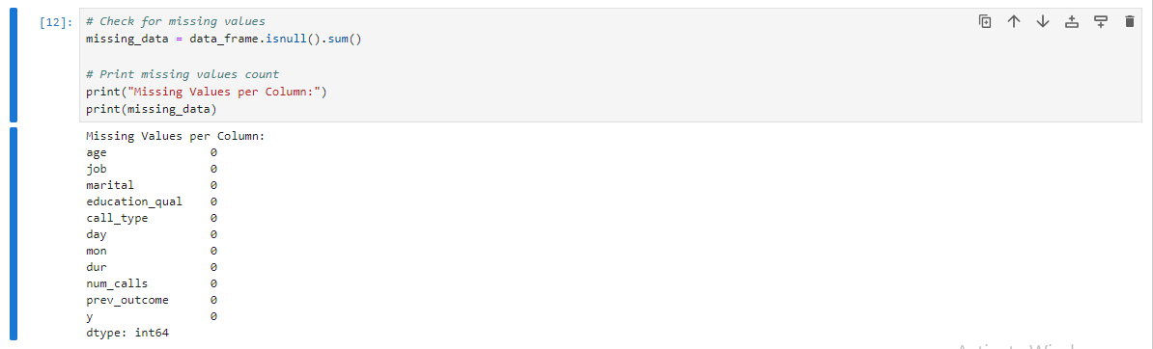
Figure 3: Jupyter Notebook Code: Identifying Missing Values

2.2.3 Techniques on Dealing with Missing Information
Once missing values are identified, several strategies can be employed to handle them:
- Imputation: Impute missing values with imputed values. Common methods include:
- Mean/Median Imputation: In case of numerical feature, choose mean or median value of the feature for imputing missing values.
- Mode Imputation: For the categorical features, the most frequently occurring value of the respective categorical feature ought to be used.
- Deletion: Then to reduce space, it is advisable to delete rows or columns with missing values. This method can be used for- Low percentage of data missing.
- Prediction Models: When two or more features are missing and there is correlation between them use machine learning models to anticipate the missing values.
Example of mean imputation:
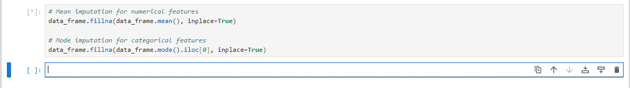
Figure 4: Jupyter Notebook Code: Imputation of Missing Values

2.2.4 Outlier Detection Techniques
Outliers are calculated values that are located far from the other values of the dataset (Smiti, A., 2020). They can affect the outcome and performance of algorithms on ML models. Common techniques for detecting outliers include:
- Statistical Methods: Outlier analysis should be done using statistical methods like the z-score or the Interquartile Range (IQR).
- Z-score Method: Outliers are values having their z-scores equal to more than a given limiting or cut off mark for instance plus or minus 3.
- IQR Method: There are some values that are beyond the range of Q1 - 1 that has been defined out of the sets of data Q1 – 1. 5 * IQR and Q3 + 1.5 * IQR.
- Visualization Methods: Visual inspection should be made by plotting data using techniques such as the use of box plot or scatter plot.
Example of IQR method for outlier detection:
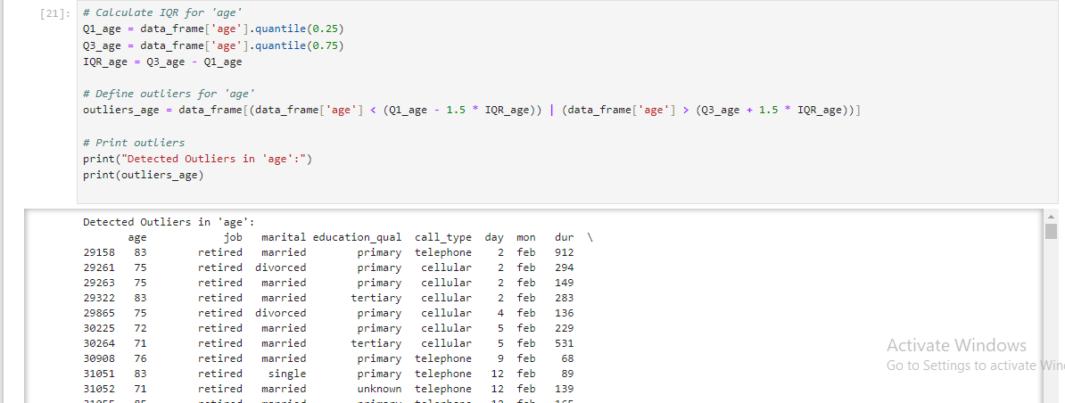
Figure 5: Jupyter Notebook Code and Output: Outlier Detection and Handling
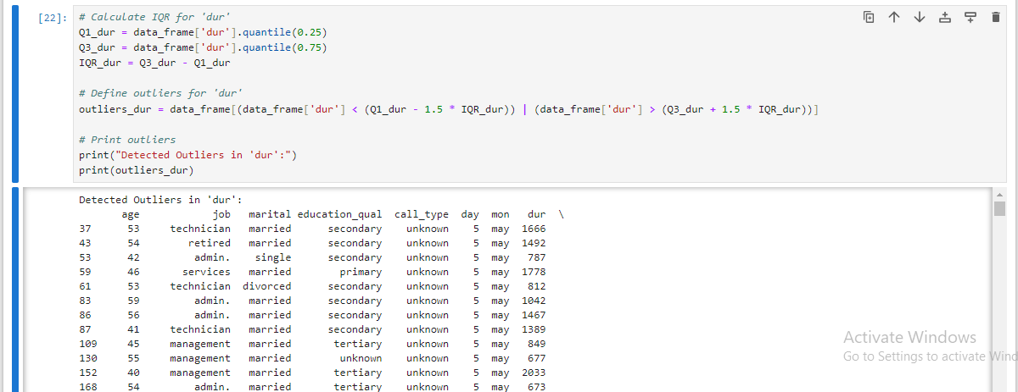
Figure 6: Jupyter Notebook Code and Output: Outlier Detection and Handling

2.2.5 Treatment of Outliers
Once outliers are identified, various strategies can be used to handle them:
- Transformation: This can be done through applying logarithmic or square root transformations for example.
- Imputation: Impute outliers when these extreme values are erroneous or beyond the sample’s possible range of values known from theory or prior research.
- Removal: Out of the calculations, the values that are presumed to be erroneous or irrelevant should not be included.
Example of removing outliers:
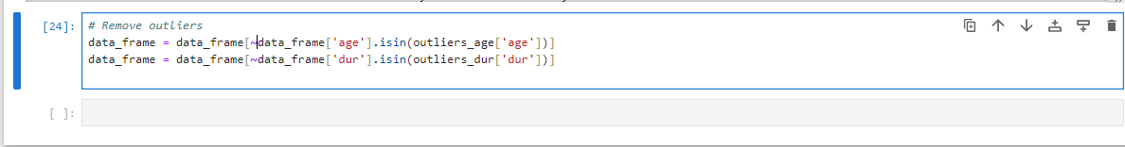
Figure 7: Jupyter Notebook Code: Outlier Removal

2.2.6 Justification of Chosen Methods
The way in which missing values and outliers are addressed is dependent on the characteristics of the data and the analysis that will be conducted.
- Imputation is ideal for use when the number of missing values is small so as to retain the size of the data set and to ensure the continuity of data.
- Deletion can be applied when the proportion of missing data is low so that it does not distort overall analysis that is being conducted.
- There are two ways in which to handle outliers, and the method used depends on the effects of outliers on the data analysis. Techniques of statistics and visualization help to maintain proper approach towards detecting and addressing outliers that is helpful for increasing model performance.
Thus the methods chosen to deal with missing values and outliers are as follows in order to improve the quality of the dataset and its conclusion.

2.3 Data Visualization
Data visualization was also useful in distinguishing patterns of aspects embedded in the data (Qin, X., Luo, Y., Tang, N. and Li, G., 2020). All the numerical and categorical variable distributions and their relation with the target variable were illustrated.

2.3.1 Visualizing Numerical Features
The next graphing techniques which were employed in attempting to analyze the data included Histograms and Scatter Plot in an endeavor to show distribution and relationships between numeric variables like age and income. For instance, the histogram showed that most of the customers fall in middle-aged bracket.
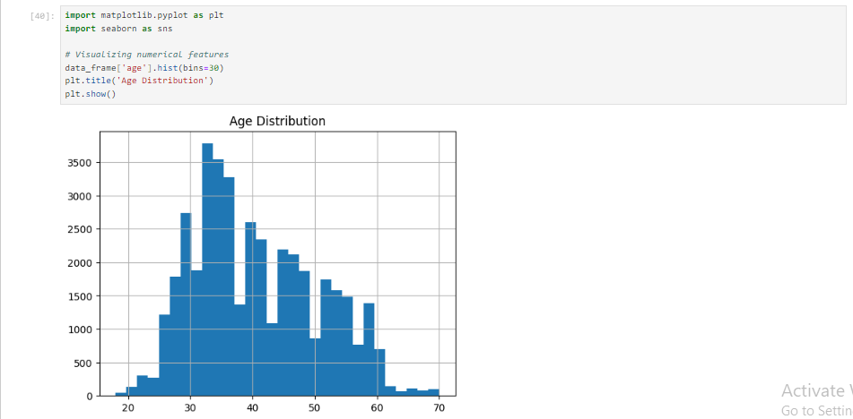
Figure 8: Jupyter Notebook Code and Output: Age Distribution Histogram

2.3.2 Visualizing Categorical Features
Bar Plots were used to show the data distribution of other nominal variables such as marital status, or gender. For example, among the married people, policy subscription was more common than among others.
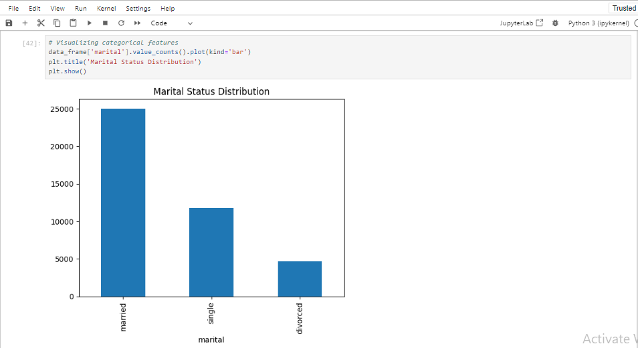
Figure 9: Jupyter Notebook Code and Output: Marital Status Distribution

2.3.3 Depiction of Relations with Target Variable
The Stacked Bar Plots were used, alongside the Box Plots to bring out the match between features (like income) and policy subscription status. The well-off customers subscribed more in terms of their numbers.
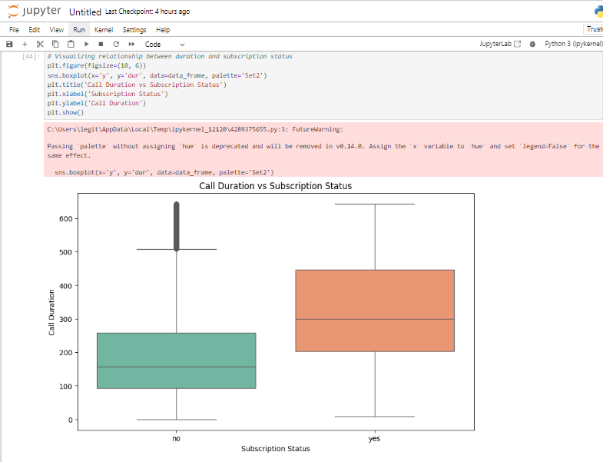
Figure 10: Jupyter Notebook Code and Output: Boxplot of Call Duration vs Subscription Status

2.3.4 Insights from Visualizations
Other influential factors include:
- Demographic information namely the age and income levels of the people were influencing matters concerning subscription.
- Customer Preferences stated the use of certain communication media provided higher conversion rates.
- Class imbalance was addressed where during data split, the sampling was done in a way that reflected an equal distribution.
All in all, data described in the section served to construct the model as well as to identify key areas and directions for action.

CHAPTER TWO: MODEL SELECTION AND TRAINING

3. 1 Model Selection

3.1.1 Overview of Binary Classification Algorithms
Nominal methodologies are categorically intended for the placement of data in one of two categories. Key algorithms include:
- Logistic Regression: Relating a test variable to one or more predictor variables, in order to predict a binary outcome. This is relatively easy to implement as well as to interpret and is most successful when used on data that is linearly separable.
- Random Forest: A machine learning technique that creates many decision trees to combine them into one in order to achieve more stable and accurate result. It is less susceptible to ‘overfitting’ and performs well in large data sets and intricate models of data association.
- Support Vector Machine (SVM): Determines the line, in the multi-dimensional space that provides the greatest margin between the two classes. It is efficient in higher dimensionality and when there is definite margin separation.
- Gradient Boosting Machines (GBM): A method in which several weak classifiers are aggregated in order to form a strong classifier. The model is capable of high accurate predictions but it has a problem with overfitting.
- K-Nearest Neighbors (KNN): Assigns the data according to the nearest neighbors based on the most frequent class. It is quite simple but the complexity is in terms of massive computations may be involved.

3.1.2 Justification for Choosing Specific Algorithms
- Logistic Regression: Originally selected because the results of this test type are easy to understand and analyze. Gives the chance of belonging to a particular class and comes handy when the data features and target relationship is nearly linear.
- Random Forest: Chosen for its stability and usefulness in the handling of the interactions between features and the other patterns. It is effective with the noisy data and gives the insights about the features.

3.1.2 Summary of Model Selection Process
This amounts to comparing the output of a variety of algorithms as a way of determining their readiness for use depending on the data, its properties and the attempted problem. In this context, Logistic Regression and Random Forest were selected as models because both of these present equal importance to interpretability and high accuracy. We know that Logistic Regression works well if there is a straight line and Random Forest if there is a curve and there is an interaction.

3. 2 Data Splitting

3.2.1 Data Splitting (Training & Testing Data Set)
The datasets are split into training and testing sets so that the models can be tested on data that the model has not been trained on (Nguyen, Q.H., Ly, H.B., Ho, L.S., Al-Ansari, N., Le, H.V., Tran, V.Q., Prakash, I. and Pham, B.T., 2021). Normally, 80% of data is used for training dataset and the remaining 20% for testing dataset. This is useful in determining the cross validation and hence how well the model is likely to perform when presented with fresh data.
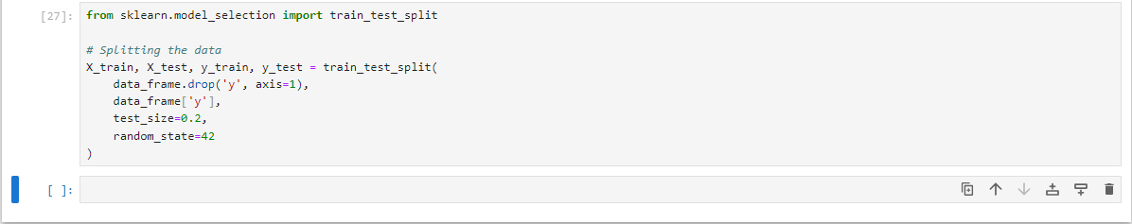
Figure 11: Python code snippet: Data Splitting using train_test_split

3.2.2 Ensuring Stratification of Target Variable
Stratification makes certain that the proportion of each class in the target variable (y) is maintained in the training as well as in the testing data. This is so as to ensure that classes are balanced particularly in imbalanced domains.
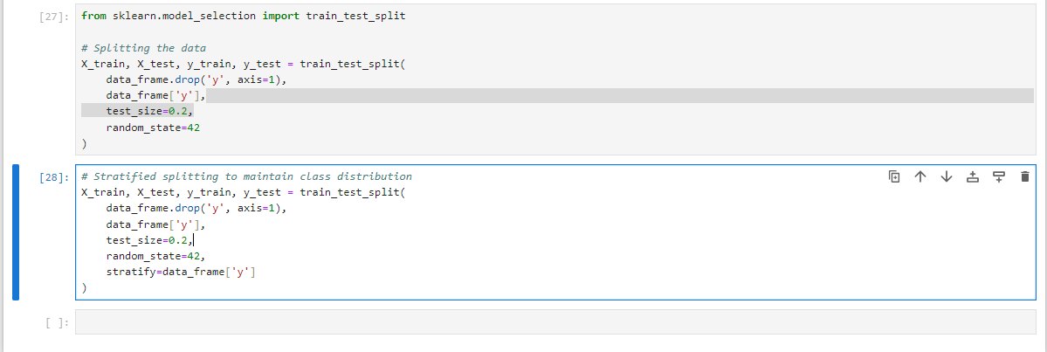
Figure 12: Jupyter Notebook Code: Stratified Data Splitting

3.2.3 Explanatory Information on Data-Splitting Technique
Cross validation as a means of splitting the data consist of the division of the data set into training and testing micro sets to construct and assay models (Varoquaux, G. and Colliot, O., 2023). Partitioning makes certain that both subsets mimic the target variable distribution since this is very crucial for accurate evaluation with minimum bias. The training set is the data on which the training of a model is based, and the testing set is the data set that defines the model’s results and its ability to work on new data.
Thus, it is possible to build a strong model that can be checked and give the necessary information about the behavior of customers and predict their subscription rate.

3. 3 Model Training

3.3.1 Training the Logistic Regression Model
As mentioned above, the logistic regression model is going to be trained performing the following steps:
Logistic Regression finds the best fit line using the training data to be able to model the relationship between the logistic features variable and the target variable.
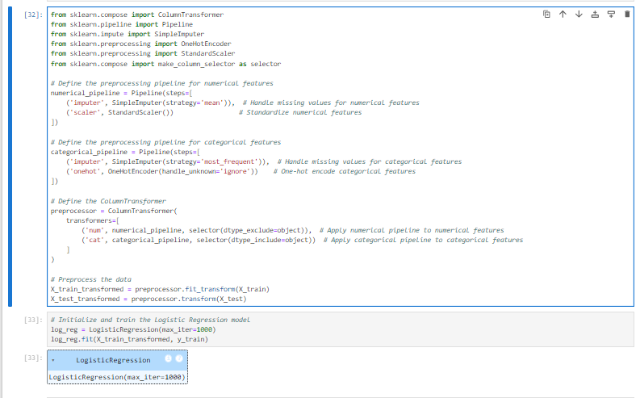
Figure 13: Jupyter Notebook Code: Preprocessing Pipeline and Logistic Regression Model

3.3.2 Training the Random Forest Model
Random forest is used the training data to build up a collection of decision trees where the final prediction is based on the aggregation of the decision of the individual trees that were built.
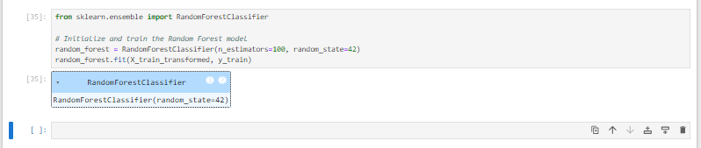
Figure 14: Jupyter Notebook Code: Random Forest Model Initialization
To conclude this section, the model selection process was initiated with a literature survey of binary classification algorithms, narrowing down the choices to those that effectively handle classification problems, specifically Logistic Regression and Random Forest (Aldelemy, A. and Abd-Alhameed, R.A., 2023). The choice of algorithm was twofold; Logistic Regression due to its simplicity and easy interpretation as well as due to the fact that Random forest is very resilient to complex data structures and non-linear relationships. The data set was therefore partitioned into training and test sets with an aim of splitting the target variable into equal proportion between the classes. This approach helped in making sure that the training of the model and the testing or validating of the model was done with data that was most relevant hence increasing the possibilities of the model or algorithm performing well when implemented.

CHAPTER THREE: MODEL INTERPRETATION AND EVALUATION

Model Interpretation
In this case, the models that were chosen were Logistic Regression and Random Forest, their decision making was explained. Hypothesis testing in Logistic Regression was linear and the Random Forest brought out new features of non-linearity by using multiple decision trees (Bhargav, D.V. and Dhanalakshmi, R., 2024, April. Performance Analysis of Logistic Regression Algorithm and Random Forest Algorithm for Predicting Product Review Analysis. In 2024). Feature importance calculation in the Random Forest process provided an additional view on the features that played the most significant role on the model in company’s customer outcome prediction.

4.2 Model Evaluation
The models were assessed using standard classification measures; accuracy, precision, recall, and F1 score. The following tables show the Classification reports of Logistic Regression and Random Forest.
Table 8: Logistic Regression Classification Report
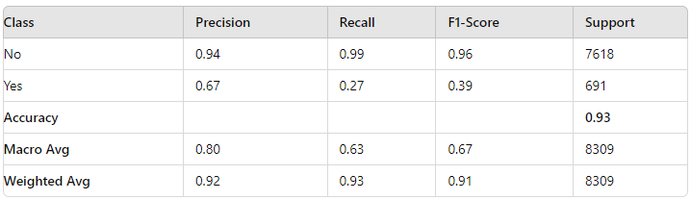
Table 9: Random Forest Classification Report
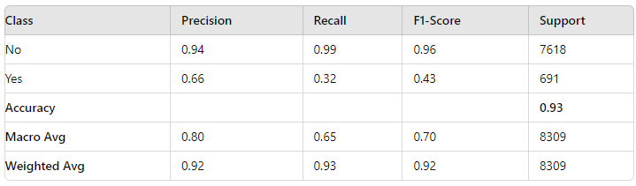

Python Code for Model Evaluation
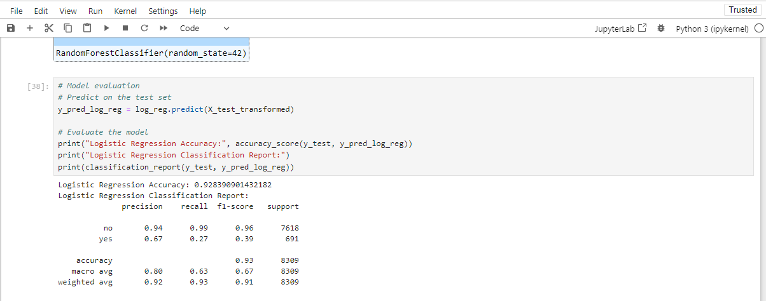
Figure 15: Jupyter Notebook Code and Output: Logistic Regression Model Evaluation
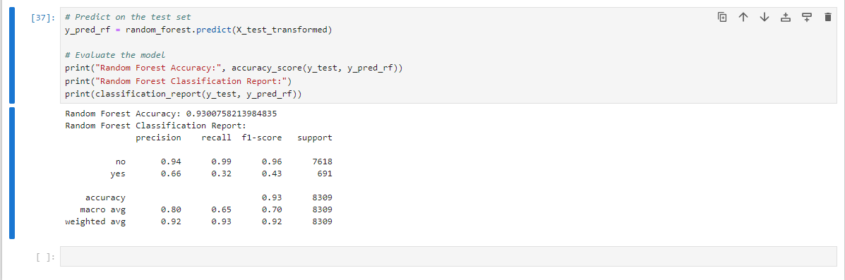
Figure 16: Jupyter Notebook Code and Output: Random Forest Model Evaluation

4.4 Hyperparameter Tuning
Tuning generally refers to the process of finding the best values for those hyperparameters that are not influenced by the data and thus are not learnable (Elgeldawi, E., Sayed, A., Galal, A.R. and Zaki, A.M., 2021). Hyperparameters are difficult to determine as the model does not learn from them; examples are the α value in Logistic Regression or the Number of Trees in Random Forest. These parameters are very important in the performance and degree of complexity of the model.
In the present work, tools such as GridSearchCV were applied to execute the search for the optimal values of hyperparameters by testing various possible configurations and their performance estimated by cross-validation.

4.4.1 Importance of Hyperparameter Tuning:
- Model Performance: By using optimizing hyperparameters the model is more likely to generalize well on the unseen data than overfitting the data or under fitting.
- Balancing Bias and Variance: Good tuning can lead to better cleaning of the data in order to avoid over simplification (biases errors) and overelaboration (variance errors at the same time).
- Efficiency: Tuning of hyperparameters means that the models are not only as accurate but also fast.
Here, regularization was fundamental in enhancing the performance of both the Logistic Regression and Random Forest models, as well as attaining the best possible accuracy and prevent overfitting in the test set.
On average, both models were accurate, and Random Forest was only slightly higher than Logistic Regression in recall for the less frequently occurring class ‘yes’. Although, few classes ‘yes/true’ had slightly better accuracy then Logistic Regression, for the majority class ‘no/ false’ the performance was more balanced.

CONCLUDING REMARKS

5.1 Summary of Key Insights and Findings
The binary classification models used for analyzing the customer data of HashSysTech Insurance offered great insights into the customer behavior and the principles effective for policy subscription. The choice of Logistic Regression and Random Forest models was made after rating them for the classification task based on their accuracy (Shah, K., Patel, H., Sanghvi, D. and Shah, M., 2020) which was estimated to be **93%**. When it came to the prediction of the “No” instances, both the models agreed in their predictive performance however the results from the Random Forest model were slightly better in the case of the “Yes” instances as far as the recall and F1-score were concerned. Based on feature importance analysis, other factors that influence customer choices were identified as the factors that help in the formulation of strategies for customizing actions to attract the more valuable clients.

5.2 Recommendations for HashSysTech Insurance
Based on the findings, the following recommendations are provided for HashSysTech Insurance:
- Targeted Marketing Campaigns: Examining these features, the model has highlighted that targeting those customers who reflect higher levels of policy subscription is a worthwhile pursuit – including communication patterns and customer participation.
- Retention Strategies for High-Risk Customers: In retention strategies, consideration should be given to those customers thought likely to churn (“Yes”). Personalized services and incentives regarding the decided key features might help to reduce churn risks.
- Continuous Monitoring and Re-Evaluation: If the customer’s preferences and the market situation change, it is more efficient to train the model with the new data from time to time to have more accurate results.

5.3 Reflection on the Model's Impact on Business Decision-Making
The various functions of the model mean that HashSysTech Insurance has a tool that can greatly assist its decision making process. With the knowledge of customers prone to subscription or churning the business can better invest in appropriate marketing channels as well as in customer retention initiatives (Janzer, A., 2020) These patterns, derived from key features of customers, help the company to concentrate on the most precious and profitable clients, which increases overall profit rates and insurance company’s competitive position on the market.
Therefore, the implementation of these machine learning models ensures HashSysTech Insurance gains insights that can be acted upon hence improving client management and designing of good business strategies (Mashrur, A., Luo, W., Zaidi, N.A. and Robles-Kelly, A., 2020).

BIBLIOGRAPHY

Gu, J., Na, J., Park, J. and Kim, H., 2021. Predicting success of outbound telemarketing in
insurance policy loans using an explainable multiple-filter convolutional neural network. Applied Sciences, 11(15), p.7147.
Chou, S.F., Horng, J.S., Liu, C.H.S. and Lin, J.Y., 2020. Identifying the critical factors of
customer behavior: An integration perspective of marketing strategy and components of attitudes. Journal of retailing and consumer services, 55, p.102113.
Alshdaifat, E.A., Alshdaifat, D.A., Alsarhan, A., Hussein, F. and El-Salhi, S.M.D.F.S., 2021. The effect
of preprocessing techniques, applied to numeric features, on classification algorithms’ performance. Data, 6(2), p.11.
Smiti, A., 2020. A critical overview of outlier detection methods. Computer Science Review, 38, p.100306.
Woods, A.D., Davis-Kean, P., Halvorson, M.A., King, K., Logan, J., Xu, M., Bainter, S., Brown, D., Clay, J.M., Cruz, R.A. and Elsherif, M., 2021. Missing data and multiple imputation decision tree.
Qin, X., Luo, Y., Tang, N. and Li, G., 2020. Making data visualization more efficient and
effective: a survey. The VLDB Journal, 29(1), pp.93-117.
Nguyen, Q.H., Ly, H.B., Ho, L.S., Al-Ansari, N., Le, H.V., Tran, V.Q., Prakash, I. and Pham, B.T., 2021. Influence of data splitting on performance of machine learning models in prediction of shear
strength of soil. Mathematical Problems in Engineering, 2021(1), p.4832864.
Varoquaux, G. and Colliot, O., 2023. Evaluating machine learning models and their
diagnostic value. Machine learning for brain disorders, pp.601-630.
Aldelemy, A. and Abd-Alhameed, R.A., 2023. Binary classification of customer’s online
purchasing behavior using Machine Learning. Journal of Techniques, 5(2), pp.163-186.
Bhargav, D.V. and Dhanalakshmi, R., 2024, April. Performance Analysis of Logistic Regression
Algorithm and Random Forest Algorithm for Predicting Product Review Analysis. In 2024 Ninth International Conference on Science Technology Engineering and Mathematics (ICONSTEM) (pp. 1-5). IEEE.
Elgeldawi, E., Sayed, A., Galal, A.R. and Zaki, A.M., 2021, November. Hyperparameter tuning
for machine learning algorithms used for arabic sentiment analysis. In Informatics (Vol. 8, No. 4, p. 79). MDPI.
Shah, K., Patel, H., Sanghvi, D. and Shah, M., 2020. A comparative analysis of logistic
regression, random forest and KNN models for the text classification. Augmented Human Research, 5(1), p.12.
Janzer, A., 2020. Subscription marketing: Strategies for nurturing customers in a
world of churn. Cuesta Park Consulting.
Mashrur, A., Luo, W., Zaidi, N.A. and Robles-Kelly, A., 2020. Machine learning for
financial risk management: a survey. Ieee Access, 8, pp.203203-203223.

